**Rosatom hosts STEM competition, learning events and cultural activities for residents of Pabna district**

*Rosatom State Corporation organized a range of scientific, educational and cultural activities for the communities of Pabna district (People's Republic of Bangladesh). The events were part of Rosatom’s commitment to fostering sciences and technology among youth and developing urban environment in the vicinity of Rooppur nuclear power plant construction site where the first batch of nuclear fuel will be delivered this week.*

**Precise Energy 2023**

More than 1200 local students took part in the Olympiad “Precise Energy 2023”, a two-week-long competition in Mathematics, Physics and Chemistry organized by JSC Atomstroyexport (Rosatom State Corporation Engineering Division), Bangladesh Atomic Energy Commission (BAEC) and Russian National Research Nuclear University MEPhI - Rosatom Flagship University.

Students from Islamic University Kushtia, Pabna University of Science and Technology (PUST), Rajshahi University of Engineering and Technology (RUET), Bangladesh Army University of Engineering & Technology participated in the senior-level competition, comprising separate written tests in Mathematics, Physics, and Chemistry. Students from 32 schools from Ishwardi and Pabna Region competed at the junior level and demonstrated their knowledge in the general science test. A jury of Russian professors from National Research Nuclear University MEPhI selected the final winners.

Among winners honored by Rosatom are Shamina Khatun from Kushtia Islamic University (in Mathematics), Sajib Mia from Rajshahi University of Engineering and Technology (in Physics), Md. Nirob Hosen from Kushtia Islamic University (chemistry), and Md. Sadmun Sakim from Bhasha Shahid Bidya School (in Junior level). The awards has been presented to the winners by Nina Dementsova, Head of Communications Department, JSC Atomstroyexport; and Aleksandr V. Nakhabov, deputy head of the department of Nuclear Physics and Engineering, МЕРhI.

Download a video

**Lectures and interactive classes**

Along with the competition, a series of interactive classes is being held in the schools of Ishwardi. During the event, the children are engaged in different activities prepared by Russian and Bangladeshi specialists of the nuclear industry and the field of education. The class consists of an introductory part (a short story about fuel, its use and energy efficiency), distribution of flyers with a nuclear pellet model, demonstration of a film about the nuclear fuel production process and a quiz. Educational kits are also donated to each school - flyers with nuclear pellets model brochures "Nuclear FAQ" and "Nuclear professions" (in Bengali), pins and shoppers. From September 17 to October 2, 16 lessons were held in 15 schools. The number of participants exceeded 800 people. The lessons will continue until October 4.

**Street art commemorates NPP construction**

On October 2, the art installation dedicated to the construction of Rooppur NPP was presented near Green City, the residential area that accommodates several thousands of local construction workers and power engineers.

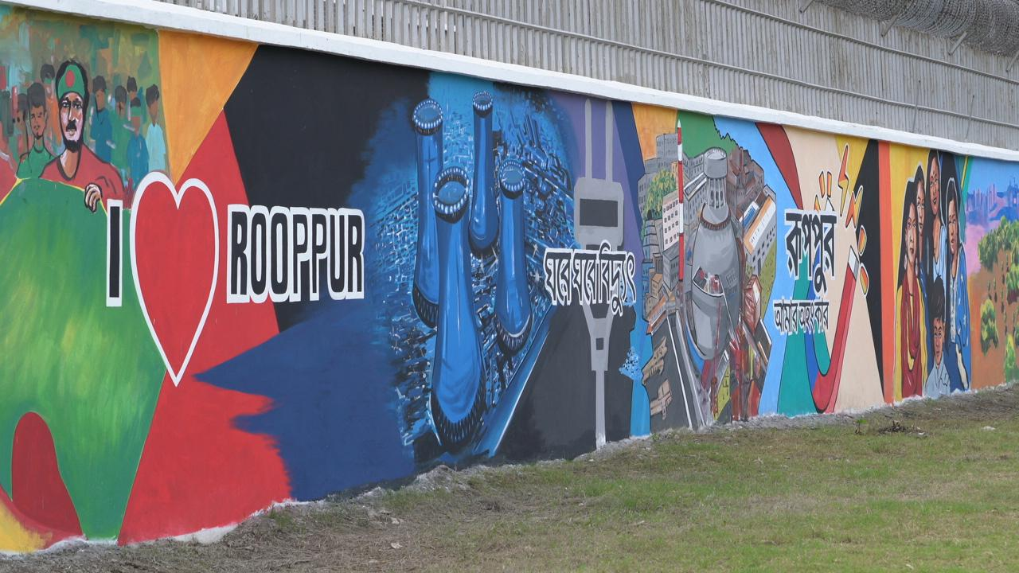

Architect Yeafesh Osman, the Minister of Science and Technology of Bangladesh and Alexey Deriy, ASE JSC Vice President - Director for Rooppur NPP Construction Project, as well as the BAEC and Rosatom representatives visited the work of the visual arts. The event was attended by a well-known artist from Dhaka Tipu Sultan, the creator of the art installation, who explained the basic ideas in detail to the guests. The installation of 380 sq.m. is dedicated to the nuclear industry of Bangladesh and demonstrates that Bangladesh has a unique generation III+ NPP project, with the commissioning of which the country will add nuclear power to the country's energy mix. The implementation of such a grandiose project became possible thanks to the coordinated and professional work of thousands of Russian and Bangladeshi specialists. All the guests noted the high level of graphic execution, made in the traditional Bengali style, and expressed confidence that such an installation would be on top of the agenda among the local residents.